**Session 1**

1. Create a class and with divide two numbers by using Scanner class (z=a/b) without try catch

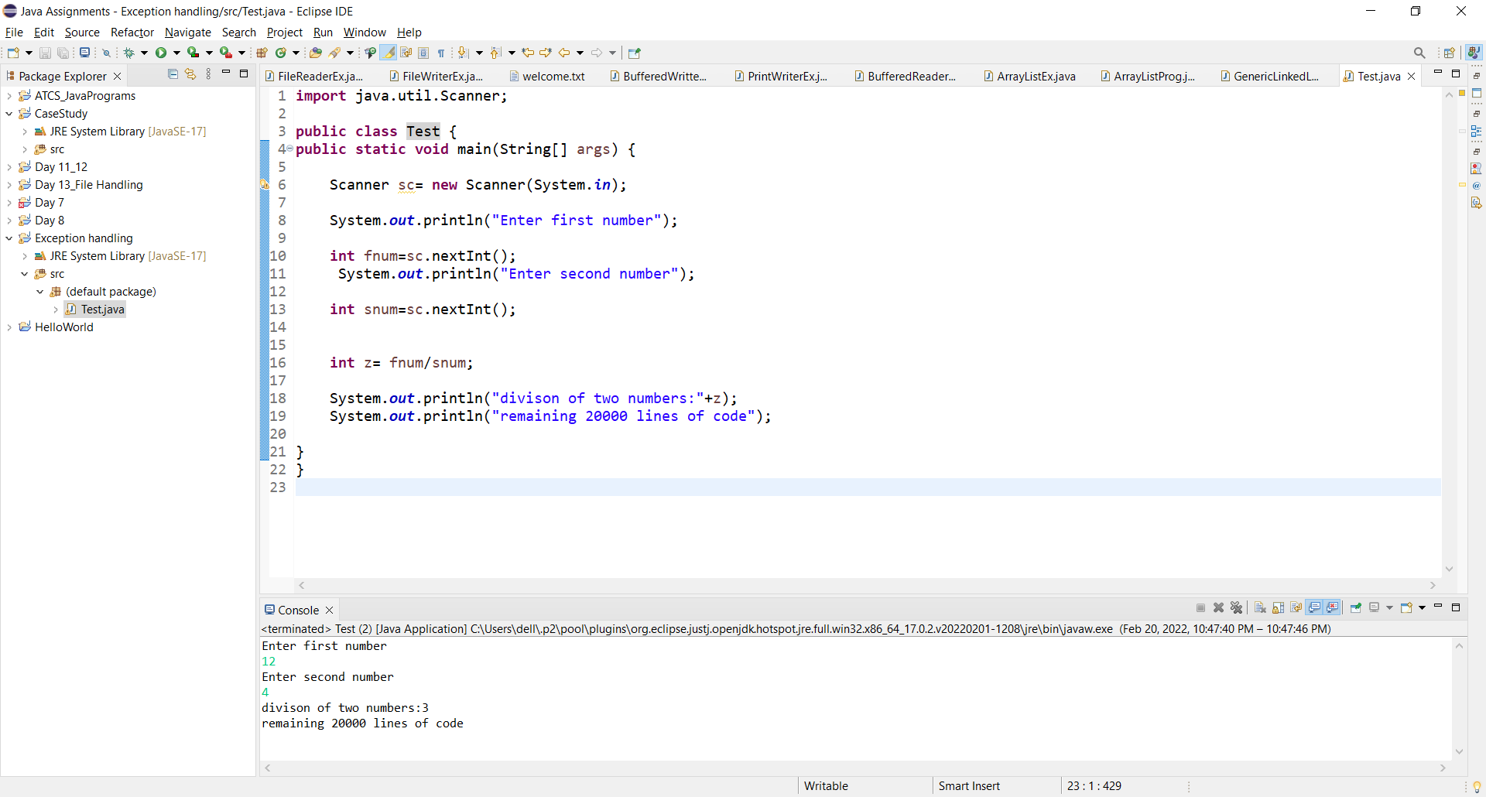

1. Create a class and take the input from by using scanner class, a end user take two numbers with division and observe which type of exception raised. And apply try catch blocks

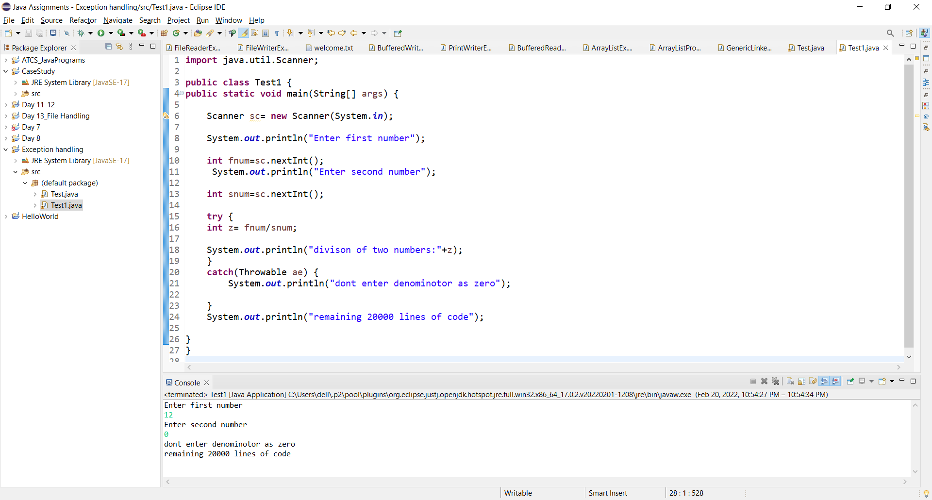

1. Create a class with single try multi catch blocks.

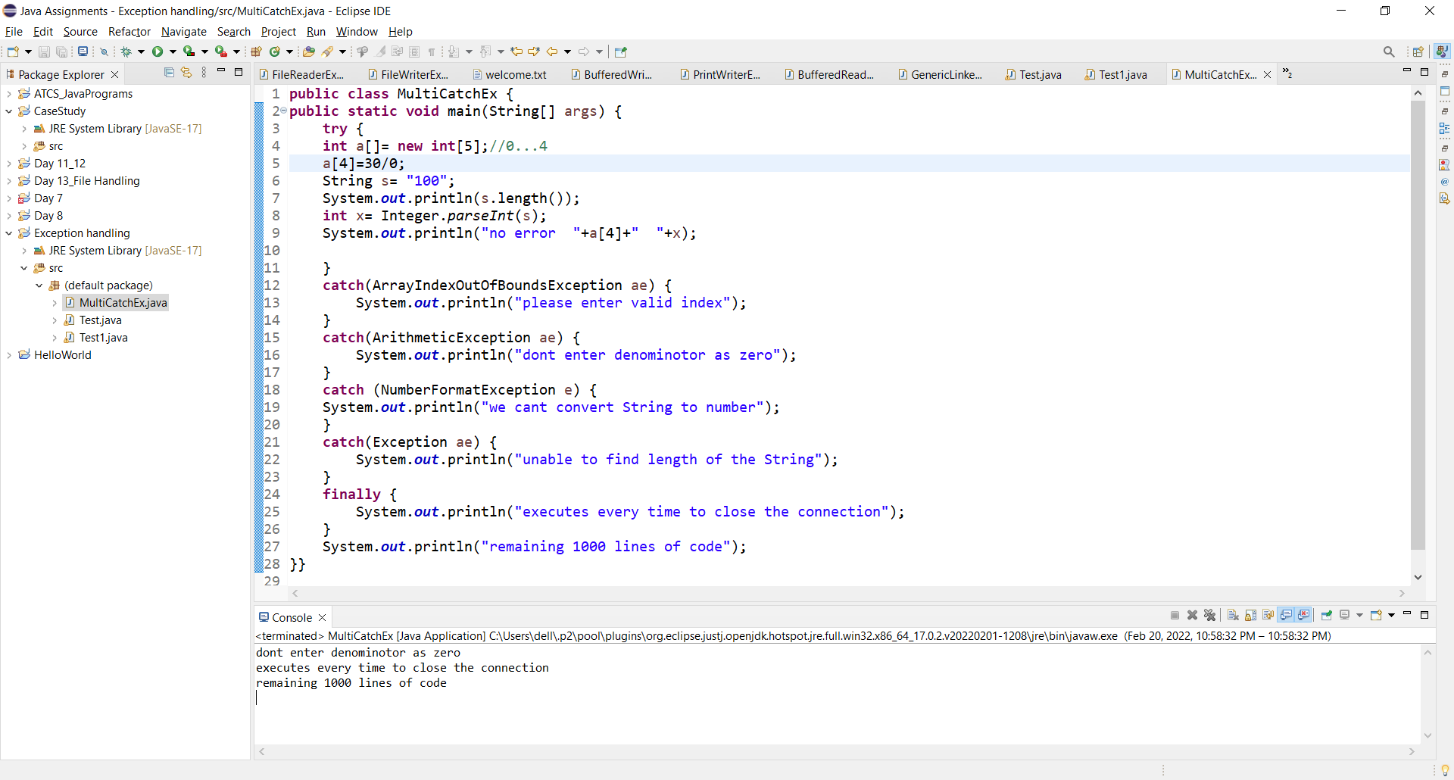

**Session 2**

1. create a class with user defined exceptions.

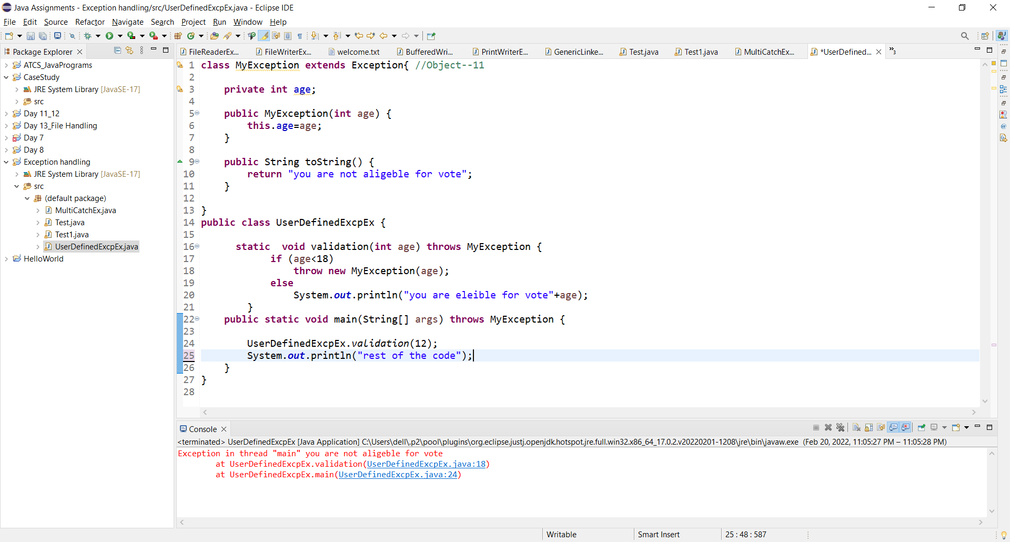

1. create a class with Marks, and valid Marks method, give some number marks are less than he/she fails otherwise pass by using throw keyword.

